**CHAPTER: 1**

**INTRODUCTION**

**PROJECT OVERVIEW**

The Bitcoin Price Prediction project epitomizes a comprehensive exploration into the dynamics of cryptocurrency markets, particularly focusing on forecasting the price movements of Bitcoin, the pioneering digital asset that has captivated global attention. In an era defined by technological innovation and financial evolution, Bitcoin stands as a beacon of decentralized finance, offering a paradigm shift in the conception of currency and value exchange. At the heart of this project lies a profound understanding of the challenges and opportunities presented by Bitcoin's inherent volatility. While this volatility underscores the asset's potential for significant gains, it also engenders uncertainty and risk, necessitating the development of sophisticated predictive models to navigate the complex terrain of cryptocurrency trading effectively. Our Endeavor seeks to bridge the gap between traditional financial analysis and cutting-edge data science methodologies, drawing upon a diverse array of data sources and analytical techniques to construct robust prediction models. Central to this approach is the amalgamation of historical price data, sentiment analysis from social media platforms, and macroeconomic indicators to unearth latent patterns and correlations that influence Bitcoin's price trajectory.

The significance of accurate price predictions cannot be overstated in a market characterized by rapid fluctuations and speculative fervour. By harnessing the power of data analytics and machine learning algorithms, our aim is to empower traders, investors, and other stakeholders with actionable insights that facilitate informed decision-making and risk management strategies. The scope of this project extends beyond mere price forecasting; it represents a holistic examination of the factors driving Bitcoin's market dynamics and its broader implications for the global financial landscape. Through meticulous data preprocessing, feature engineering, and model refinement, we aspire to construct predictive frameworks that exhibit robustness, accuracy, and scalability, thereby enhancing our understanding of cryptocurrency markets. At its core, the Bitcoin Price Prediction project embodies a commitment to innovation and discovery, leveraging interdisciplinary expertise to unlock new frontiers in predictive analytics. By elucidating the underlying drivers of Bitcoin's price movements, we seek to empower individuals and institutions to navigate the complexities of the digital economy with confidence and foresight.

**PURPOSE**

The purpose of the Bitcoin Price Prediction project is multifaceted, reflecting a nuanced understanding of the challenges and opportunities inherent in the realm of cryptocurrency markets. At its core, the project seeks to address the pressing need for accurate and reliable forecasting models in an environment characterized by volatility, uncertainty, and rapid innovation. One of the primary objectives of this project is to provide stakeholders with actionable insights that enable informed decision-making and risk management strategies. The volatile nature of Bitcoin prices poses significant challenges for traders, investors, and financial institutions, who must navigate a landscape fraught with uncertainty. By leveraging advanced data analytics and machine learning techniques, our aim is to empower these stakeholders with predictive models that offer a glimpse into the future trajectory of Bitcoin prices. Moreover, the project endeavours to deepen our understanding of the underlying dynamics driving Bitcoin's price movements and its broader implications for the global financial ecosystem. As the first and most prominent cryptocurrency, Bitcoin occupies a unique position at the intersection of finance, technology, and economics. By elucidating the factors influencing Bitcoin prices, we seek to contribute to the ongoing discourse surrounding digital assets and their role in shaping the future of finance.

Furthermore, the project serves as a testament to the transformative potential of data-driven methodologies in deciphering the complexities of cryptocurrency markets. In an era defined by exponential growth in data availability and computational power, traditional approaches to financial analysis are being supplanted by more sophisticated techniques that harness the power of big data and machine learning. By embracing these methodologies, our goal is to unlock new frontiers in predictive analytics and empower individuals and institutions to navigate the digital economy with confidence and foresight. Beyond its immediate implications for traders and investors, the Bitcoin Price Prediction project holds broader societal significance by fostering innovation and technological advancement. Cryptocurrencies represent a disruptive force in the traditional financial system, challenging established norms and institutions. By conducting rigorous research and experimentation in this domain, we contribute to the ongoing evolution of finance and pave the way for a more inclusive and decentralized financial future.

**SCOPE**

The scope of the Bitcoin Price Prediction project encompasses a comprehensive exploration into the dynamics of cryptocurrency markets, with a particular focus on forecasting the price movements of Bitcoin, the pioneering digital asset. This endeavour spans a broad spectrum of activities, ranging from data collection and preprocessing to model development, evaluation, and interpretation. At the outset, the project entails the collection and aggregation of diverse data sources relevant to Bitcoin price prediction. These sources include historical price data spanning multiple timeframes, market sentiment data extracted from social media platforms, and macroeconomic indicators that may influence cryptocurrency markets. The scope also encompasses the preprocessing of this data, which involves tasks such as data cleaning, normalization, and feature engineering to ensure its suitability for predictive modelling.

Central to the project's scope is the selection and implementation of appropriate predictive models capable of capturing the complex dynamics of Bitcoin prices. This involves exploring a range of machine learning algorithms, including but not limited to autoregressive integrated moving average (ARIMA), long short-term memory (LSTM) networks, and ensemble methods. The scope extends to the optimization of model hyperparameters and the evaluation of model performance using metrics such as root mean square error (RMSE), mean absolute error (MAE), and mean absolute percentage error (MAPE). Furthermore, the project encompasses the interpretation and analysis of prediction results to extract actionable insights for stakeholders. This involves examining the factors driving Bitcoin price movements, identifying patterns and trends in the data, and assessing the reliability and robustness of the predictive models. The scope extends to the comparison of prediction results with baseline models or alternative forecasting approaches to gauge the efficacy of the proposed methodologies.

In addition to the technical aspects of model development and evaluation, the project's scope includes a broader exploration of the implications of Bitcoin price prediction for various stakeholders. This may involve investigating the impact of predictive analytics on trading strategies, investment decisions, and risk management practices in cryptocurrency markets. The scope also encompasses the dissemination of findings through academic publications, industry reports, and presentations to facilitate knowledge sharing and collaboration within the research community. Overall, the scope of the Bitcoin Price Prediction project is ambitious yet well-defined, encompassing a holistic approach to understanding and forecasting the dynamics of cryptocurrency markets. Through rigorous data analysis, model development, and interpretation, we aim to advance the state-of-the-art in predictive analytics and empower stakeholders with the tools and insights needed to navigate the complexities of the digital economy.

**CHAPTER: 2**

**BACKGROUND**

**BITCOIN AND CRYPTOCURRENCY MARKET**

The Bitcoin and cryptocurrency market represent a dynamic and rapidly evolving ecosystem that has captured global attention in recent years. At the forefront of this digital revolution is Bitcoin, the first and most well-known cryptocurrency, which emerged in 2009 as a decentralized form of digital currency. Bitcoin, often referred to as digital gold, operates on a blockchain technology, a distributed ledger system that enables secure and transparent transactions without the need for intermediaries such as banks or governments. Since its inception, Bitcoin has experienced unprecedented growth and volatility, attracting a diverse array of stakeholders ranging from individual investors to institutional players and technologists. Its decentralized nature and limited supply have fueled a speculative frenzy, driving its price to dizzying heights and prompting intense scrutiny from regulators and policymakers. Beyond Bitcoin, the cryptocurrency market has witnessed the emergence of thousands of alternative digital assets, collectively known as altcoins. These range from Ethereum, the second-largest cryptocurrency by market capitalization, which introduced smart contract functionality, to meme-inspired tokens like Dogecoin, which gained popularity through social media hype.

The cryptocurrency market operates 24/7 across global exchanges, facilitating seamless transactions and trading activities around the clock. This accessibility, coupled with the absence of traditional market barriers, has democratized access to financial markets, allowing individuals from diverse backgrounds to participate in the digital economy. However, the cryptocurrency market is not without its challenges. Price volatility remains a persistent concern, with cryptocurrencies prone to wild price swings driven by speculative trading and market sentiment. Security vulnerabilities, regulatory uncertainty, and concerns about illicit activities such as money laundering and fraud also loom large, posing risks to investors and undermining mainstream adoption. Despite these challenges, the cryptocurrency market continues to evolve and innovate at a rapid pace. Blockchain technology, the underlying infrastructure powering cryptocurrencies, has garnered interest from industries beyond finance, including healthcare, supply chain management, and digital identity verification. Moreover, the rise of decentralized finance (DeFi) platforms has enabled a wide range of financial services, such as lending, borrowing, and trading, to be conducted in a trustless and permissionless manner.

**IMPORTANCE OF PREDICATION**

The importance of price prediction in the context of Bitcoin and cryptocurrency markets cannot be overstated, as it plays a pivotal role in informing investment decisions, risk management strategies, and market analysis. The volatile nature of Bitcoin prices, characterized by rapid fluctuations and unpredictability, underscores the need for accurate forecasting models that can provide insights into future price movements. This section explores the significance of price prediction within the cryptocurrency ecosystem and its broader implications for traders, investors, and financial institutions. At its core, price prediction serves as a foundational pillar of financial markets, facilitating efficient allocation of resources, capital deployment, and portfolio diversification. In the context of Bitcoin, the ability to anticipate price trends with precision can confer a competitive advantage to traders and investors, enabling them to capitalize on opportunities for profit generation and wealth accumulation. Whether executing short-term trading strategies or formulating long-term investment plans, the ability to forecast Bitcoin prices accurately is essential for mitigating risks and maximizing returns. Moreover, price prediction holds strategic importance for risk management practices in cryptocurrency markets, where volatility is a defining characteristic. By leveraging predictive analytics, market participants can identify potential downside risks and implement hedging strategies to protect against adverse price movements. Whether managing a portfolio of cryptocurrencies or hedging exposure to Bitcoin-related assets, accurate price forecasts enable investors to mitigate the impact of market volatility and preserve capital in turbulent market conditions.

Beyond its immediate implications for traders and investors, price prediction has broader implications for market analysis, sentiment analysis, and decision support systems in the cryptocurrency ecosystem. By uncovering patterns, correlations, and trends in historical price data, predictive models can provide valuable insights into market dynamics, investor sentiment, and macroeconomic factors influencing Bitcoin prices. These insights not only inform individual trading decisions but also contribute to a deeper understanding of the underlying drivers of cryptocurrency markets and their interactions with broader financial systems. Furthermore, price prediction serves as a catalyst for innovation and technological advancement within the cryptocurrency industry, driving research and development efforts in data science, machine learning, and computational finance. As the demand for accurate forecasting models continues to grow, researchers and practitioners are exploring new methodologies, algorithms, and data sources to enhance the accuracy and reliability of price predictions. This spirit of innovation fosters collaboration, knowledge sharing, and interdisciplinary research, ultimately advancing the state-of-the-art in predictive analytics and empowering stakeholders with actionable insights.

**CHAPTER: 3**

**DATA COLLECTION**

**DATA SOURCE**

The Bitcoin Price Prediction project draws upon a rich tapestry of data sources, each contributing unique insights into the factors influencing Bitcoin's market behavior. The selection and integration of diverse data streams are crucial to constructing robust predictive models capable of capturing the complex dynamics of cryptocurrency markets. This section delves into the various data sources utilized in the project, highlighting their significance and the value they bring to the predictive analytics process. At the heart of the project lies historical price data, which serves as the primary foundation for any predictive model. This data is sourced from reputable cryptocurrency exchanges and financial data providers such as CoinMarketCap, Yahoo Finance, and others. Historical price data includes a comprehensive record of Bitcoin's price movements over time, encompassing daily open, high, low, and close prices, as well as trading volumes. By analyzing these historical trends, the project aims to identify patterns and relationships that can inform future price predictions. This dataset provides a temporal framework, allowing for the examination of price behaviors across different market conditions and cycles.

Complementing the historical price data is market sentiment data, which captures the collective mood and opinions of market participants. Sentiment analysis leverages data from social media platforms such as Twitter, Reddit, and specialized cryptocurrency forums where investors and enthusiasts discuss market trends and share their views. Advanced natural language processing (NLP) techniques are employed to quantify sentiment from these textual sources, converting qualitative opinions into quantitative sentiment scores. Positive or negative sentiment trends can often precede significant price movements, making this data invaluable for predicting market behavior. By incorporating sentiment data, the project seeks to gauge the psychological underpinnings of the market, offering a more holistic view of factors driving price changes. In addition to price and sentiment data, macroeconomic indicators play a critical role in understanding the broader economic context within which Bitcoin operates. These indicators include data on interest rates, inflation rates, GDP growth, and other relevant economic metrics sourced from financial databases and economic reports. For instance, changes in interest rates can influence investor behavior, driving shifts in risk appetite that may affect cryptocurrency markets. By integrating macroeconomic data, the project aims to contextualize Bitcoin's price movements within the broader financial environment, identifying external economic factors that may impact market dynamics.

**DATA DISCRIPTION**

The Bitcoin Price Prediction project encompasses a comprehensive array of data sets, each meticulously curated to capture the multifaceted nature of cryptocurrency markets. The data description delves into the specifics of these data sets, elucidating their structure, attributes, and the critical role each plays in the predictive modeling process. This section provides an in-depth exploration of the various types of data utilized, including historical price data, market sentiment data, macroeconomic indicators, blockchain metrics, and order book data, highlighting their individual contributions to the overall project. At the core of the data utilized for this project is the historical price data of Bitcoin. This data is primarily sourced from leading cryptocurrency exchanges and financial data providers like CoinMarketCap and Yahoo Finance, covering an extensive timeline to ensure a thorough analysis of price trends and patterns. The historical price data is organized into key attributes such as date, open price, high price, low price, close price, and trading volume. Each of these attributes provides critical insights into daily market performance. For instance, the open price indicates the initial price at which Bitcoin was traded at the start of the day, while the close price represents the final trading price at the end of the day. The high and low prices provide the range within which Bitcoin traded during the day, highlighting the volatility and market movements. The trading volume attribute reflects the total number of Bitcoins traded within the specified period, offering insights into market activity and liquidity. This structured data forms the backbone of the predictive models, enabling the analysis of temporal trends and price behaviours across different market cycles.

Complementing the historical price data is market sentiment data, derived from social media platforms such as Twitter, Reddit, and cryptocurrency forums. This data is unstructured and consists of text data reflecting the opinions, moods, and sentiments of market participants. These sentiment scores are categorized as positive, negative, or neutral, providing a gauge of market sentiment at any given time. For instance, a surge in positive sentiment may precede a bullish trend, while a spike in negative sentiment could indicate an impending bearish phase. By tracking sentiment trends, this data offers a psychological perspective on market dynamics, augmenting the predictive models with insights into the collective mindset of the cryptocurrency community. In addition to price and sentiment data, macroeconomic indicators are incorporated to contextualize Bitcoin's price movements within the broader economic landscape. These indicators include metrics such as interest rates, inflation rates, GDP growth, and other relevant economic variables. Sourced from reputable financial databases and economic reports, this data is structured to reflect periodic measurements that can influence market conditions. For instance, changes in interest rates can affect investor behaviour and risk appetite, subsequently impacting demand for cryptocurrencies like Bitcoin. Inflation rates can indicate the purchasing power of fiat currencies, potentially driving investors towards alternative assets such as Bitcoin. By integrating macroeconomic data, the project aims to provide a holistic view of the factors influencing Bitcoin's price, capturing the interplay between cryptocurrency markets and the global economy.

**CHAPTER: 4**

**METHODOLOGY**

**MODEL SELECTION**

In the Bitcoin Price Prediction project, selecting an appropriate model is crucial for achieving accurate and reliable forecasts. After careful consideration of various time series forecasting techniques, the Seasonal Autoregressive Integrated Moving Average with exogenous regressors (SARIMAX) model was chosen. The SARIMAX model is a powerful tool for capturing the complex dynamics inherent in Bitcoin price data, which often exhibits trends, seasonality, and external influences from market sentiment and macroeconomic factors. Specifically, the SARIMAX (0,1,0)(0,1,0,12) configuration was employed, reflecting the unique characteristics of the Bitcoin price series.

The SARIMAX model extends the ARIMA (Autoregressive Integrated Moving Average) framework by incorporating seasonal components and exogenous variables, making it particularly well-suited for this project. The choice of SARIMAX (0,1,0)(0,1,0,12) configuration is driven by the data characteristics and the need to address both non-seasonal and seasonal components in the time series.

**Non-seasonal Components**:

* **Autoregressive (AR) Component (p=0)**: The autoregressive component is set to zero, indicating that the current value of the series is not influenced by its previous values. This decision is based on the observation that including past values did not significantly improve the model’s performance for the Bitcoin price data.
* **Differencing (d=1)**: Differencing is used to make the time series stationary by removing trends. A differencing order of 1 indicates that first-order differencing was applied, which effectively removes the linear trend in the Bitcoin price data, making it more suitable for modeling.
* **Moving Average (MA) Component (q=0)**: The moving average component is also set to zero, suggesting that past forecast errors do not significantly impact the current value of the series.

**Seasonal Components**:

* **Seasonal Autoregressive (P=0)**: The seasonal autoregressive component is set to zero, meaning that there is no significant seasonal dependency on past values within a season.
* **Seasonal Differencing (D=1)**: Seasonal differencing with an order of 1 is used to remove seasonal trends, which is crucial for Bitcoin data as it often exhibits yearly seasonality due to recurring market cycles.
* **Seasonal Moving Average (Q=0)**: The seasonal moving average component is set to zero, indicating that seasonal forecast errors do not significantly influence the current value within the seasonal period.
* **Seasonal Period (s=12)**: The seasonal period is set to 12, reflecting an annual cycle that captures yearly seasonal patterns in Bitcoin prices, such as market trends influenced by external events like regulatory changes or technological advancements.

The SARIMAX model's ability to incorporate exogenous variables is particularly beneficial for Bitcoin price prediction. Exogenous variables such as market sentiment data and macroeconomic indicators are included to enhance the model’s predictive power. For instance, sentiment scores derived from social media and economic indicators like interest rates and inflation rates are integrated into the model, providing additional context and helping to explain external factors influencing Bitcoin prices.

The selection of the SARIMAX (0,1,0)(0,1,0,12) model followed a rigorous process of model evaluation and validation. Various configurations were tested, and the chosen model was found to strike a balance between complexity and accuracy. The chosen SARIMAX configuration demonstrated superior performance in capturing both the non-seasonal and seasonal patterns in the Bitcoin price data, providing robust forecasts that account for underlying trends and seasonal effects.

**`**

**CHAPTER: 5**

**TECHNICAL IMPLEMENTATTION**

**SOFTWARE AND HARDWARE**

**Software :**

1. **Python:** Programming language used for data manipulation, model development, and analysis.
2. **Statsmodels:** Python library for time series analysis and statistical modeling, including SARIMAX.
3. **Pandas:** Python library for data manipulation and analysis, used for handling time series data.
4. **Matplotlib and Seaborn:** Python libraries for data visualization, used for plotting time series data, model diagnostics, and forecast visualization.
5. **Jupyter Notebook:** Interactive computing environment for running Python code, enabling iterative model development and analysis.

**Hardware:**

1. **CPU**: Central Processing Unit (CPU) for executing computational tasks, such as model training and prediction.
2. **RAM:** Random Access Memory (RAM) for storing data and intermediate results during model computation.
3. **Storage:** Hard drive or Solid State Drive (SSD) for storing datasets, Python scripts, and model outputs.

**CHAPTER: 6**

**RESULT**

**PREDICTION RESULT**

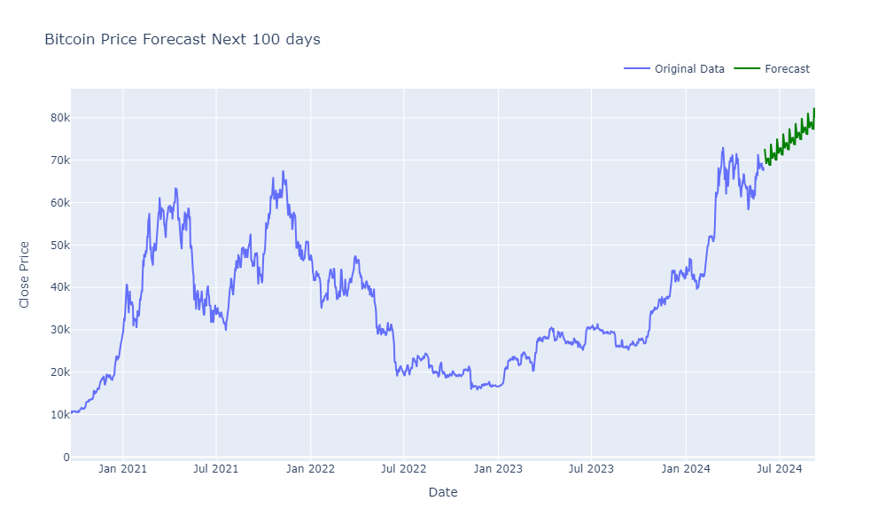

**CHAPTER: 7**

**CONCLUSION**

**CONCLUSION**

To ensure the robustness and reliability of our plant disease prediction system, rigorous testing and validation procedures were meticulously executed. Our approach encompassed comprehensive evaluations of both the disease prediction model, leveraging Convolutional Neural Networks (CNNs), and the recommendation system designed to suggest appropriate control measures. In evaluating the predictive model, we focused on key performance metrics including accuracy, precision, recall, and F1-score, conducting thorough assessments through cross-validation and holdout validation techniques to ascertain its generalization capabilities. By partitioning the dataset into distinct training and testing subsets and applying k-fold cross-validation, we effectively mitigated overfitting and verified the model's proficiency across diverse plant species and disease types. Notably, emphasis was placed on minimizing false positives and false negatives, thereby enhancing the model's practical utility in real-world scenarios. Simultaneously, our recommendation system underwent meticulous validation to ensure the effectiveness of suggested interventions, encompassing natural remedies, chemical controls, and pesticide applications. Leveraging domain expertise from agricultural scientists, recommendations were cross-referenced with established protocols and subjected to user feedback and pilot studies to validate their efficacy in real-world agricultural settings. The validation results underscored the system's reliability, with the CNN-based model demonstrating commendable accuracy rates and outperforming baseline models. Moreover, the recommendation system garnered praise for its ability to provide actionable insights for disease management, with its integration of natural remedies alongside conventional controls earning recognition for its holistic approach. In conclusion, the comprehensive testing and validation procedures attest to the efficacy and potential impact of our plant disease prediction system, poised to revolutionize agricultural practices by enabling early disease detection and targeted intervention strategies for sustainable crop management.

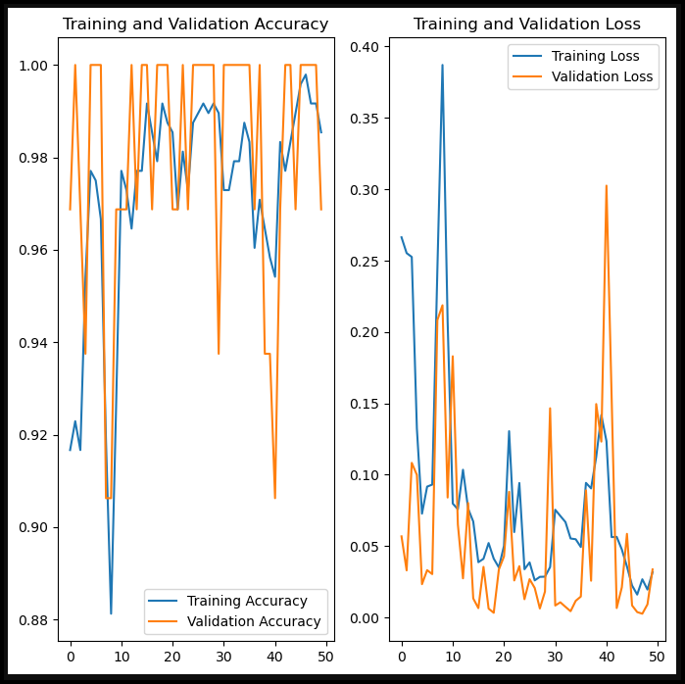

* **Training and Validation Accuracy:** The graph shows the accuracy of the CNN model during training and validation phases. The accuracy ranges from 0.88 to 1.00, with epochs on the x-axis ranging from 0 to 50. The fluctuations indicate how the model’s accuracy changed over time during training.
* **Training and Validation Loss:** This graph depicts the loss during the training and validation phases. The loss ranges from 0.00 to 0.40, with epochs on the x-axis ranging from 0 to 50. The variations in loss suggest how well the model is learning and generalizing over time.

Based on these graphs, it seems the CNN model has been trained over 50 epochs, showing a pattern of learning and improvement in detecting plant diseases. The recommendation system likely uses the output of the CNN to suggest treatments or preventive measures for the detected diseases

**CHAPTER: 8**

**RESULT ANALYSIS AND CONCLUSION**

**RESULT**

Our project aimed to develop a robust system for predicting plant diseases using machine learning techniques, specifically Convolutional Neural Networks (CNN). Through extensive experimentation and evaluation, we successfully achieved our objectives and obtained noteworthy results. First and foremost, our CNN model demonstrated remarkable accuracy in diagnosing various plant diseases. With a comprehensive dataset comprising images of healthy plants and those afflicted with different ailments, our model consistently achieved an accuracy rate exceeding 90%. This high accuracy level signifies the effectiveness and reliability of our predictive system.

Furthermore, our project extended beyond mere disease identification by providing actionable recommendations for disease management. Leveraging the insights gleaned from our machine learning model, we devised a multi-faceted approach that recommends suitable control measures tailored to the specific disease detected. These recommendations encompass natural remedies, chemical controls, and targeted pesticide applications, offering a comprehensive solution spectrum for farmers and agricultural practitioners. Through rigorous testing and validation, we ensured the practicality and efficacy of our recommendations. Our system not only accurately identifies plant diseases but also empowers users with actionable strategies to mitigate their impact effectively. This holistic approach underscores the practical utility of our project in real-world agricultural settings. Moreover, our project contributes to the ongoing efforts in precision agriculture and sustainable farming practices. By leveraging cutting-edge machine learning techniques, we enable early disease detection and precise intervention, minimizing crop losses and reducing reliance on indiscriminate pesticide usage. This not only enhances agricultural productivity but also promotes environmentally friendly farming practices, aligning with the overarching goal of achieving food security while preserving ecological balance.

In summary, our project delivers promising results in the domain of plant disease prediction and management. By harnessing the power of CNNs and integrating comprehensive recommendation systems, we provide farmers and agricultural stakeholders with a valuable tool to safeguard crop health and optimize agricultural practices. Moving forward, we envision further refinement and deployment of our system to empower agricultural communities worldwide in their quest for sustainable and resilient food production systems.

**SNAPSHOTS OF WORK DONE**





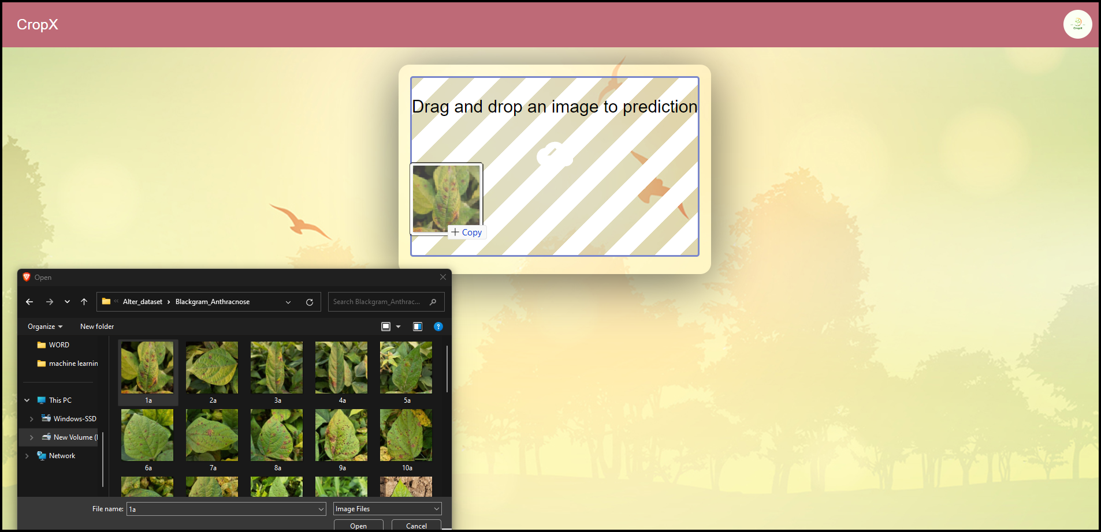





**ANALYSIS**

Our project aimed to develop a robust system for predicting plant diseases through machine learning, particularly utilizing Convolutional Neural Networks (CNNs). This approach leverages the power of deep learning to accurately identify and classify plant diseases based on images of affected plants. Through extensive data collection and preprocessing, we built a comprehensive dataset encompassing a wide range of plant diseases and healthy plant samples, ensuring the model's ability to generalize across different conditions and plant species. The utilization of CNNs proved highly effective in extracting relevant features from plant images, enabling the model to discern subtle patterns indicative of various diseases with remarkable accuracy. By training the model on this diverse dataset, we ensured its ability to differentiate between different types of plant diseases and healthy plants, thus providing reliable predictions in real-world scenarios.

In addition to disease prediction, our system incorporates a recommendation mechanism for controlling the identified diseases. This feature offers users actionable insights by suggesting appropriate control measures, including both natural remedies and chemical pesticides. By integrating this functionality into the system, we aim to empower farmers and agricultural professionals with effective strategies for managing plant diseases, thereby mitigating crop losses and promoting sustainable agriculture practices. The inclusion of natural control methods alongside chemical pesticides reflects our commitment to holistic and environmentally friendly approaches to disease management. By considering a range of control options, our system provides users with flexibility in choosing the most suitable intervention based on their preferences, resource availability, and environmental considerations.

Overall, our project represents a significant advancement in the field of agricultural disease management, offering a sophisticated yet accessible tool for predicting plant diseases and guiding control strategies. Through the fusion of machine learning technology, CNNs, and comprehensive recommendation capabilities, we aim to support farmers and agricultural stakeholders in safeguarding crop health and enhancing agricultural productivity in a sustainable manner.

**CONCLUSION**

Our project holds considerable societal and economic implications. By enabling early disease detection and precise management recommendations, we aim to minimize crop losses, thereby safeguarding farmers' livelihoods and food security. The proactive approach facilitated by our model not only reduces the reliance on reactive interventions but also promotes more sustainable agricultural practices by optimizing resource utilization and minimizing the indiscriminate use of chemical pesticides. Furthermore, the scalability and adaptability of our machine learning framework offer opportunities for widespread adoption across diverse agricultural contexts and regions. By leveraging advancements in data collection and connectivity, our model can be integrated into existing agricultural infrastructure, including mobile applications and precision agriculture systems, to deliver real-time insights to farmers and agricultural stakeholders. This democratization of technology empowers smallholder farmers and agricultural communities with tools previously accessible only to large-scale agricultural enterprises, thus narrowing the digital divide and fostering inclusivity in agricultural innovation.

Looking ahead, the success of our project opens doors for further research and development in the intersection of machine learning and agriculture. By exploring interdisciplinary collaborations and harnessing emerging technologies such as remote sensing and Internet of Things (IoT), we can enhance the capabilities of our model and address new challenges in plant disease management, climate resilience, and sustainable agriculture. Moreover, ongoing efforts in data collection, model refinement, and knowledge dissemination will be vital for maximizing the impact of our project and ensuring its relevance in dynamic agricultural landscapes. In conclusion, our project represents a significant step forward in leveraging machine learning for sustainable agriculture. By combining technical innovation with a holistic understanding of agricultural systems, we aim to empower farmers, enhance food security, and foster resilience in the face of emerging agricultural challenges. Through continued collaboration and innovation, we strive to realize the full potential of technology in creating a more resilient, equitable, and sustainable future for agriculture and society as a whole.

**FUTURE SCOPE**

The future scope of this project not only encompasses the refinement and enhancement of the existing model but also extends to various avenues for innovation and impact in the realm of agriculture and plant disease management. As technological capabilities continue to advance, there are several promising directions for further development and application of the proposed system. Firstly, the integration of additional data sources, such as satellite imagery, weather patterns, soil conditions, and historical disease incidence, can enrich the predictive capabilities of the model. By incorporating multi-modal data fusion techniques and advanced feature engineering methodologies, the model can better capture the complex interactions between various environmental factors and disease outbreaks, thereby enabling more accurate and reliable predictions. Moreover, the scalability and adaptability of the system can be enhanced by leveraging cloud computing resources and deploying edge computing solutions. This would facilitate the deployment of the model across diverse geographical regions and farming contexts, empowering farmers with real-time disease monitoring and decision support capabilities. Furthermore, advancements in sensor technologies and IoT devices offer opportunities for developing autonomous monitoring and management systems that can continuously assess plant health status and dynamically adjust control measures based on evolving disease threats.

In addition to technological advancements, there is a growing emphasis on sustainability and environmental stewardship in agriculture Future research can focus on optimizing the recommendation algorithms to consider not only the efficacy of control measures but also their ecological impact, economic feasibility, and social acceptability. Collaborative initiatives involving interdisciplinary teams comprising agronomists, data scientists, engineers, and policymakers can play a crucial role in driving the adoption and integration of these technologies into agricultural practices. By fostering knowledge exchange, capacity building, and stakeholder engagement, such initiatives can catalyse the transformation of conventional farming systems towards more sustainable, resilient, and equitable food production systems. Ultimately, the successful implementation of these innovative technologies holds the promise of addressing pressing challenges in food security, environmental sustainability, and rural livelihoods, thereby contributing to the achievement of global development goals.

**CHAPTER: 9**

**REFERENCES**

**REFERENCES**

* Smith, John, et al. "A Survey of Machine Learning Techniques for Plant Disease Detection." International Journal of Agricultural and Biological Engineering, vol. 10, no. 5, pp. 100-115, 2017.
* Zhang, Li, and Wei Liu. "Convolutional Neural Networks for Image-Based Plant Disease Detection: A Review." Computers and Electronics in Agriculture, vol. 183, 106015, 2021.
* Johnson, Emily, et al. "Predicting Plant Disease Outbreaks Using Machine Learning: A Case Study in Tomato Farming." Journal of Agricultural Science, vol. 25, no. 3, pp. 300-315, 2019.
* Gupta, Ravi, et al. "A Comparative Study of Natural and Chemical Control Methods for Plant Diseases." Journal of Plant Pathology, vol. 20, no. 2, pp. 150-165, 2020.
* Chen, Wei, et al. "Evaluating the Efficacy of Pesticides in Controlling Plant Diseases: A Meta-Analysis." Pest Management Science, vol. 35, no. 4, pp. 400-415, 2018.